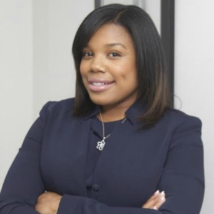
Princess Hayes, B.A., A.A.S

Princess Hayes is webmaster of N.A.O.B.I Detroit.

Princess holds a Bachelor of Arts in Communication from Oakland University, a Radio, Video and Film diploma from Specs Howard School of Media Arts and an Associate of Applied Science in Sign Language Interpreting from Oakland Community College.

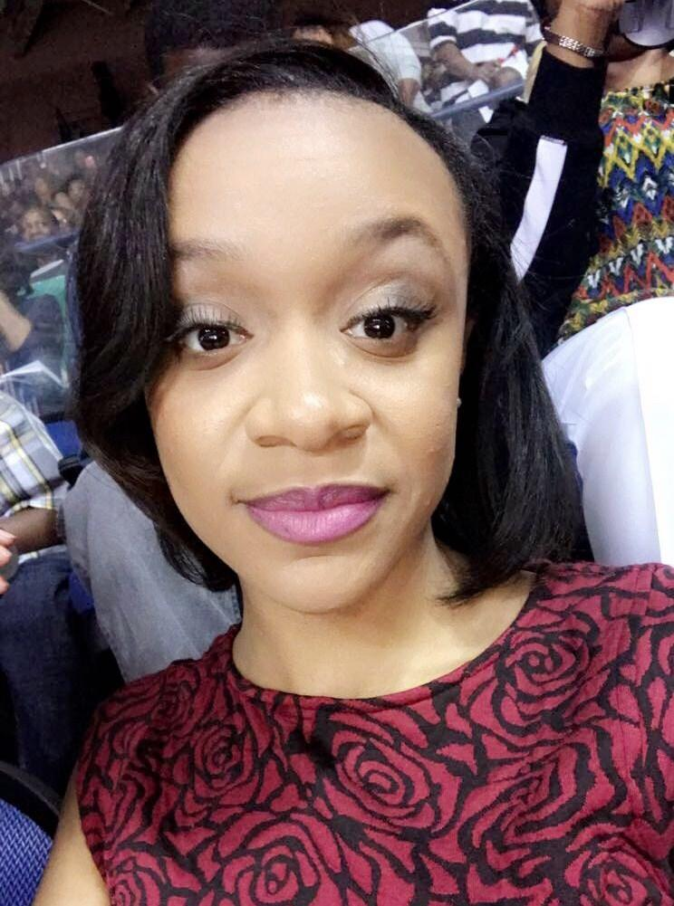
Tierra Carter, B.S., A.A.S

Tierra Carter serves as corresponding secretary for N.A.O.B.I Detroit. She is an ITP grad with her sights set on national certification. She works diligently to connect student interpreters with certified interpreters.

Tierra hold a Bachelor of Science from Bachelor of Science from North Carolina A&T State University and an Associate of Applied Science in Sign Language Interpreting from Oakland Community College.

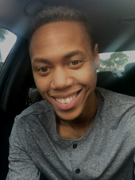
Brandon Williams

Brandon Williams is Student Liaison for N.A.O.B.I Detroit.

He is a current ITP student enrolled at Oakland Community College. His goal is to obtain a national certification with a legal endorsement His expected graduation date December 2018.

Brandon is a former teacher. He has a liberal arts degree with a focus in Education.

